Week 4: Predictive Modeling and Optimization in Logistics
Logistics Data Analyst Internship | Predicting Shipment Delivery Time
Dataset note: This project uses a hypothetical, simulated dataset created for learning and demonstration. It is not actual DataCo or company shipment data.

1. Objective
The objective of this task is to build and evaluate a predictive model for a logistics metric and use the model's insights to propose operational improvements. The selected target is Delivery_Time_Days, which estimates the number of days required for a shipment to reach its destination.

2. Problem Definition
Delivery delays affect customer satisfaction, inventory availability, and logistics costs. A model that estimates delivery time from shipment distance, volume, transportation mode, weather, traffic, priority, and estimated transportation cost can help planners identify shipments that may need additional attention. The model is a decision-support prototype, not a replacement for dispatchers or live tracking systems.

3. Dataset and Features
A reproducible hypothetical dataset of 500 shipment records was generated using a fixed random seed. This makes the exercise repeatable while ensuring the results are clearly labelled as simulated.
Feature | Type | Purpose
Shipment_ID | Identifier | Unique row identifier; excluded from model features.
Shipment_Distance_km | Numeric | Distance between origin and destination.
Shipment_Volume_units | Numeric | Approximate shipment size/volume.
Transportation_Mode | Categorical | Road, Rail, Air, or Sea.
Weather_Condition | Categorical | Clear, Rain, or Storm.
Traffic_Level | Categorical | Low, Medium, or High.
Priority | Categorical | Standard or Express.
Estimated_Transportation_Cost_INR | Numeric | Estimated transport cost in INR.
Delivery_Time_Days | Numeric target | Number of days to predict.
The generated data follows illustrative relationships—for example, longer distances generally increase travel time, and weather or traffic can add delays. Because these relationships were programmed into the simulated data, performance metrics should not be interpreted as evidence of real-world accuracy.

4. Data Preparation
- Load the CSV file with pandas and check that required columns are present.
- Remove duplicate records and convert the target to numeric format.
- Exclude Shipment_ID because an identifier has no useful operational meaning as a predictor.
- Separate predictors (X) from target (y), then create an 80% training and 20% test split using a fixed random state.
- Impute missing numeric values with the median and categorical values with the most frequent category.
- Apply one-hot encoding to categorical predictors. Preprocessing is kept inside a scikit-learn pipeline so transformations are learned from training data rather than the test set.

5. Model Selection and Rationale
Two regression models are compared. Linear Regression is a simple, interpretable baseline that estimates a linear relationship between input variables and delivery time. Random Forest Regression combines many decision trees and can capture nonlinear patterns and interactions, such as the way distance may affect delivery time differently by transportation mode. Random Forest is selected when it achieves the lower test RMSE in this simulated experiment.

6. Training, Validation, and Evaluation
The data is split into training and testing sets (80:20). The training set is used to fit models. Five-fold cross-validation on the training set provides a more stable estimate of generalization. The held-out test set is used once for final comparison.
Metrics: MAE is the average absolute prediction error in days and is easy to explain operationally. RMSE penalizes larger errors more strongly and is useful when large misses are costly. R-squared indicates the proportion of target variation explained by the model relative to a mean-only baseline; it should not be used alone.

6.1 Results on the simulated dataset
The following scores were obtained in the generated experiment. The Python script re-runs training and writes its own evaluation CSV; small differences may occur if software versions or data generation are changed.
Model | Test MAE (days) | Test RMSE (days) | Test R-squared
Linear Regression | 1.1654 | 1.7731 | 0.9667
Random Forest | 0.8708 | 1.3386 | 0.9810
In this run, Random Forest achieved lower test MAE and RMSE and a higher R-squared than Linear Regression. This supports selecting it for the demonstration. The model's apparent performance is influenced by the simplified relationships used to generate the synthetic dataset.

7. Visual Diagnostics
The charts below are diagnostic views. Actual-versus-predicted points closer to the diagonal indicate smaller errors. The error histogram shows whether errors are centered near zero and whether there are large misses.
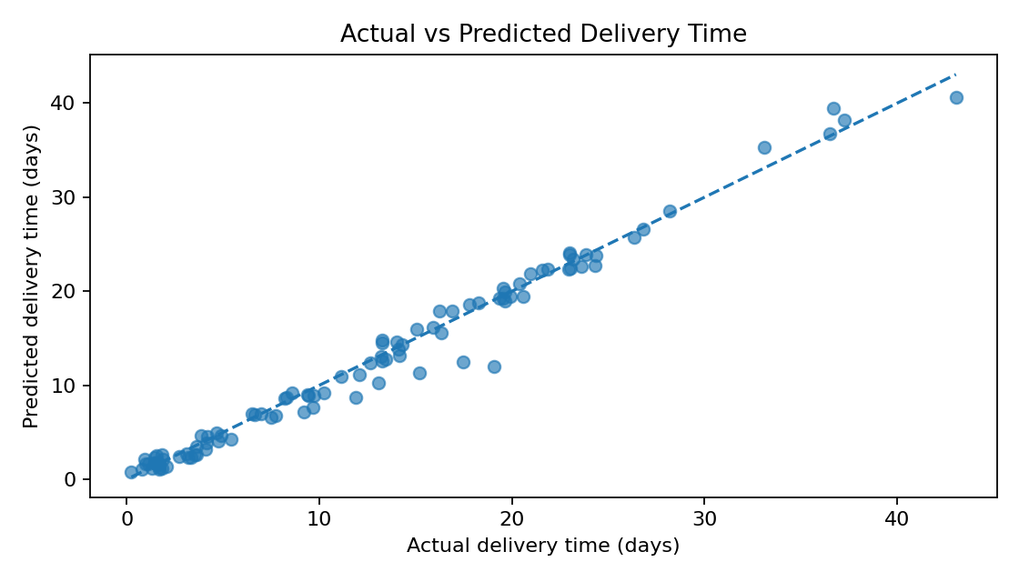
Figure 1. Actual versus predicted delivery time on the held-out test set.
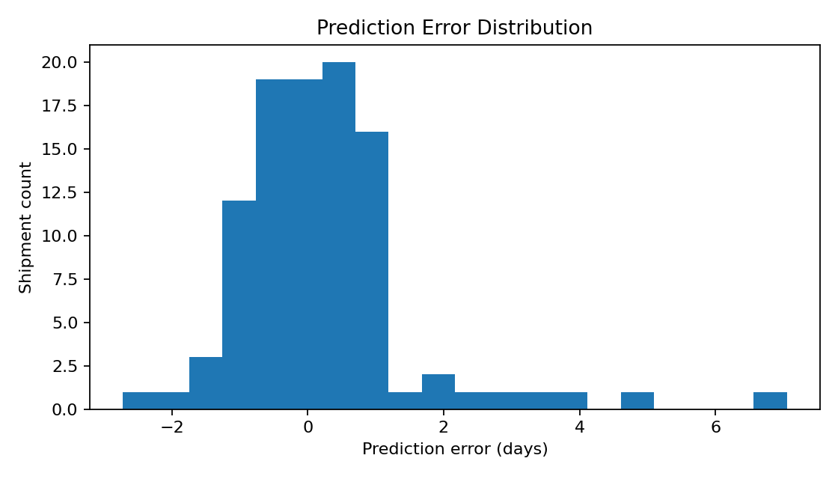
Figure 2. Distribution of prediction errors (actual minus predicted).
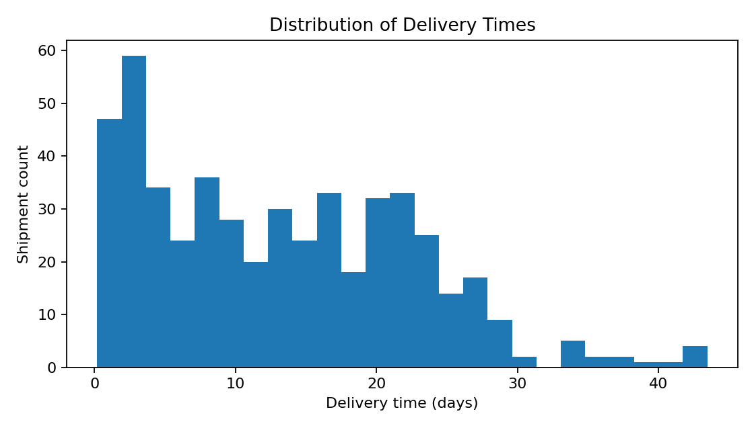
Figure 3. Distribution of simulated delivery times.
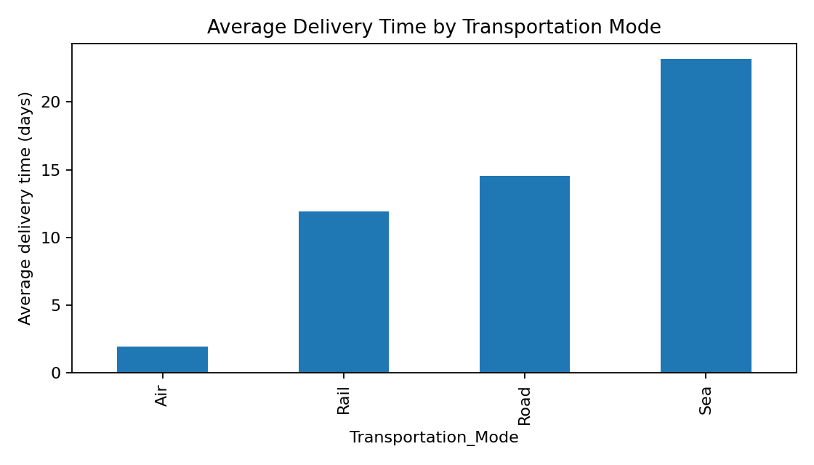
Figure 4. Average simulated delivery time by transportation mode.
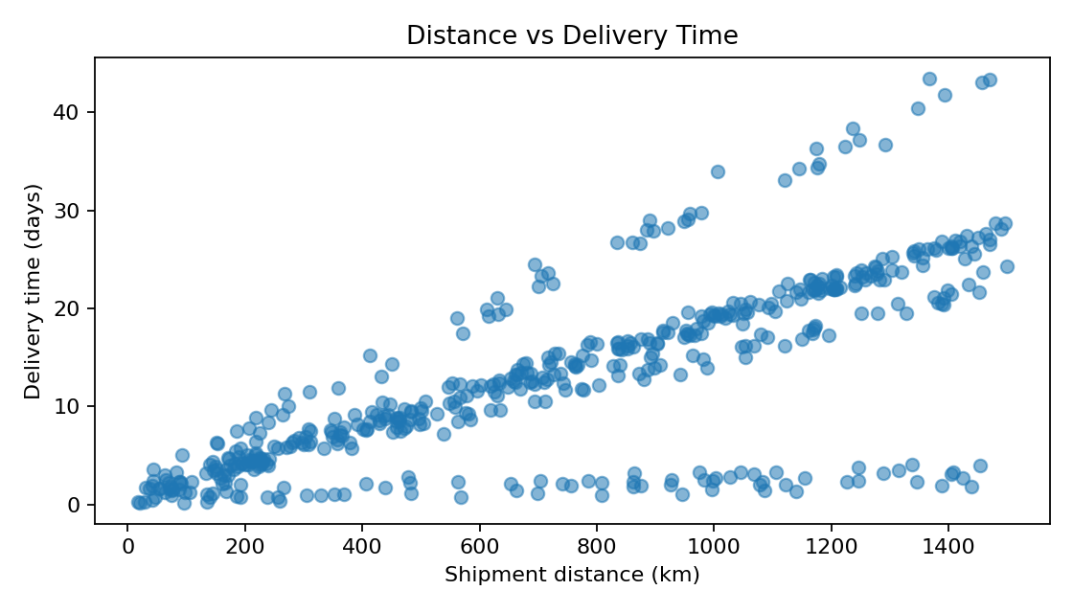
Figure 5. Relationship between distance and simulated delivery time.

8. Python Code Snippet
The complete runnable implementation is provided in logistics_predictive_model.py. The excerpt below shows the core training and evaluation loop:
models = {
"Linear Regression": LinearRegression(),
"Random Forest": RandomForestRegressor(
n_estimators=150, min_samples_leaf=2,
random_state=42, n_jobs=-1
)
}
for name, estimator in models.items():
pipeline = Pipeline([
("preprocessor", preprocessor),
("model", estimator)
])
pipeline.fit(X_train, y_train)
predictions = pipeline.predict(X_test)
mae = mean_absolute_error(y_test, predictions)
rmse = np.sqrt(mean_squared_error(y_test, predictions))
r2 = r2_score(y_test, predictions)

9. Hyperparameter Tuning and Further Validation
The included script compares a fixed Random Forest configuration with Linear Regression and performs five-fold cross-validation. A next improvement is to tune n_estimators, max_depth, and min_samples_leaf with GridSearchCV using only the training set. After selecting parameters, report the final held-out test score. For real operational deployment, use a time-based split when shipment records are dated, because random splitting can leak future patterns into training.

10. Optimization Strategies Based on Predictions
- Proactive exception management: flag shipments whose predicted delivery time exceeds the service-level target, then review them before dispatch or while in transit.
- Route and mode planning: compare predicted delivery times and costs for feasible modes or routes. Choose the lowest-cost option that still meets the delivery deadline, rather than minimizing cost alone.
- Weather and traffic buffers: add contingency time or recommend earlier dispatch for shipments exposed to severe weather or high traffic.
- Priority allocation: reserve express capacity for shipments with strict deadlines or high business impact; avoid automatically upgrading every shipment.
- Capacity planning: aggregate predicted shipment volumes and expected delivery windows to support vehicle, labor, and warehouse-slot allocation.
- Continuous monitoring: compare predicted and actual delivery times, track MAE/RMSE monthly, investigate drift, and retrain when operating conditions change.
These are proposed strategies inferred from the modeled feature relationships, not measured savings. A real optimization study would require route alternatives, capacity limits, service-level penalties, actual costs, and business constraints.

11. Process Flow
Define prediction problem → generate/load hypothetical dataset → validate and preprocess features → split train/test data → train baseline and ensemble models → validate with 5-fold cross-validation → evaluate MAE, RMSE, and R² → inspect diagnostic plots → propose operational actions → monitor real outcomes before deployment.

12. Conclusion
This task demonstrates an end-to-end predictive analytics workflow for logistics delivery-time forecasting. It compares an interpretable baseline with a nonlinear ensemble, evaluates predictions using error-based metrics and cross-validation, and translates the results into practical recommendations for exception management, route planning, contingency buffers, and resource allocation. Since the dataset is hypothetical, real deployment would require historical shipment records, time-aware validation, and a pilot to verify whether the recommendations improve service and cost.

Appendix: Reproducibility
Install dependencies with: pip install pandas numpy matplotlib scikit-learn. Keep logistics_predictive_model.py and logistics_predictive_dataset.csv in the same folder, then run: python logistics_predictive_model.py. The script exports model_evaluation_results.csv and diagnostic charts under visualizations/.

